

**Lesson 2.1 Supplement:**

**Creating a Cloud9 Workspace**

**Introduction**

This supplement explains how to set up a workspace with Cloud9, a professional cloud-based development environment for web developers. Two activities in Lesson 2.1 (Activity 2.1.3 Protocols and Bandwidth and Activity 2.1.4 HTML and CSS) use a Cloud9 workspace. Your teacher may have you complete either of the activities first. Before using a Cloud9 workspace, you will need to:

* Create a Cloud9 account
* Link your Cloud9 account to your GitHub account
* Create a Cloud9 workspace

Many uses of the Internet and Web require you to fill out forms that ask you to create a username and password. Cyber hygiene requires careful consideration of what a website is requesting and how you will handle it. Managing passwords for dozens of websites is a fact of life for those who use the Web for a variety of tasks. You should practice these considerations consciously and reflect upon them as you complete the supplement.

Materials

* Email address
* GitHub username and password

Procedure

**Part I: Sign up for a Cloud9 account**

Creating an account for a web service raises many cyber security issues. First, let’s consider those cybersecurity issues.

An important principle of cybersecurity is that you don’t have to provide information when someone asks you a question. When a website asks for personal information, you have options.

Can I refuse to answer? That’s safest, but a business can refuse service if you don’t answer questions they require to be answered.

Can I make up information?

* You are required by law to provide your correct name and social security number to the armed services and to someone who pays you.
* It is illegal to use someone else’s identity.
* It is legal to use an alias, but if you use an alias when selling goods or services, many state’s laws require you to register that alias.
* It can be illegal to provide a false age indicating you are older than you are.
* A poorly chosen alias can give away personal information such as enthusiasm for a particular sport, your location, or affiliation with a particular school.

1. As a class, discuss what is ethical and what is best practice when a website asks for information online. Record your personal conclusion from the discussion.

To create the Cloud9 account, you will be instructed to click a link in a confirmation email. Email is almost always sent without encryption, so there are hostile parties who can exploit this semi-public knowledge of your friends’ email addresses and email patterns. There are three distinct vulnerabilities from email:

* + - Attachments can carry malware. The vulnerability is not exploited until you open the attachment. Never open attachments from an unknown source.
    - Some email clients will automatically display or preview media embedded in an email. Avoid opening email that appears to be spam.
    - It is easy to send email that appears to be from someone else. Be skeptical of email and stay alert. Alerts that appear to be from a bank, website, or service should not require you to follow a link. To protect against fraudulent requests, access messages from such organizations by browsing to their official site instead of following the link in an email. Links can open malicious JavaScript in the browser. If you suspect you have followed a link to a page that might serve malicious JavaScript, close all tabs of the browser and restart the browser.

Note that there are two circumstances when it is considered safe to follow a link in an email:

* An email that you just asked a website to send to you.
* An email from a friend that contains personal writing that confirms it is from the friend. If in doubt, contact the friend in another **channel**. (A phone call, text message, social media site, separate email, Skype chat are each independent channels.)

Attacks against computer systems that work by fooling people into giving up information or executing some code are called **social engineering** attacks.

1. Describe a malicious email that would fool some people into following a link or opening an attachment, and describe how you would know not to fall for that social engineering attack.
2. Create a Cloud9 account as follows.
3. Navigate to <https://c9.io> and select **SIGN IN**.



1. Provide an email address and select **Sign Up**.

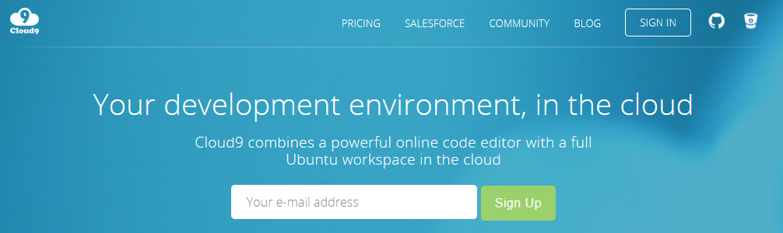

1. Cloud9 asks for a person’s name and requires three letters minimum. Cloud9 also asks you to create a username using only lowercase letters. Respond accordingly to Cloud9’s questions and confirm your details as shown below.

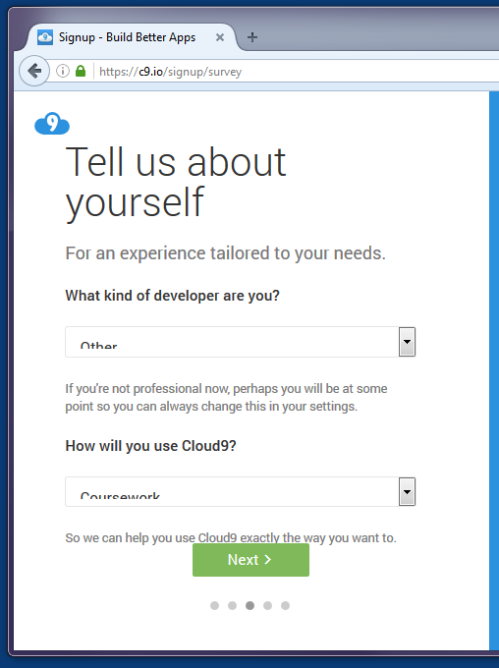 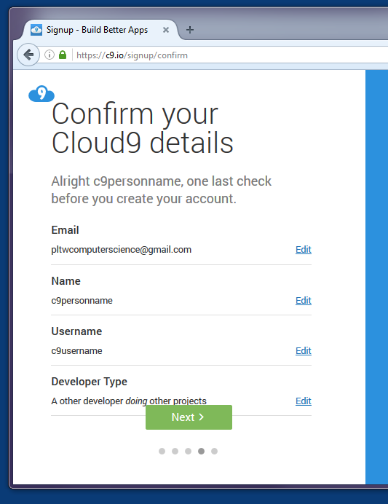

When you create credentials on a website, there are four pieces of information that are especially important to have a record of, as shown in the table below. Do not record passwords on this activity document because passwords should be kept secure, preferably encrypted.

**My credentials for websites**

|  |  |  |  |
| --- | --- | --- | --- |
| **Domain name** | **email address you provided** | **username** | **password** |
| c9.io |  |  |  |
|  |  |  |  |

After you have confirmed the credentials you entered, Cloud9 sends you an email to confirm your email address.

1. Click the link in the email.

**Part II: Link to your GitHub Account**

1. Log in to Cloud9.

You will land on your dashboard.

1. Select **Repositories** from the left menu bar of the dashboard.
2. Select **Connect** to connect to GitHub.

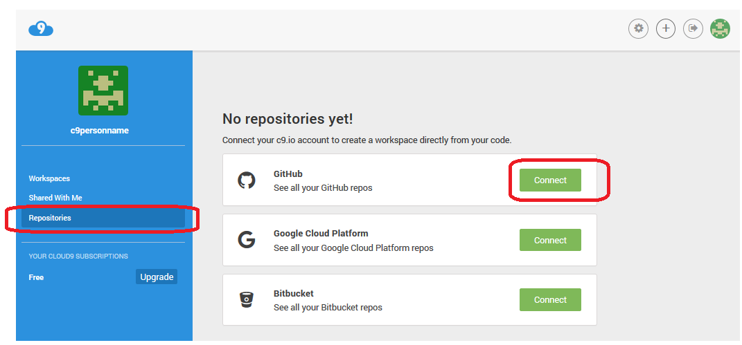

1. Authenticate to GitHub with your GitHub username and password. Remember, before you type secure credentials, check that the browser is using **HTTPS** and that the domain name has the correct ending: github.com.
2. Select **Authorize application**. Note that you are giving Cloud9 read and write access to your GitHub data.

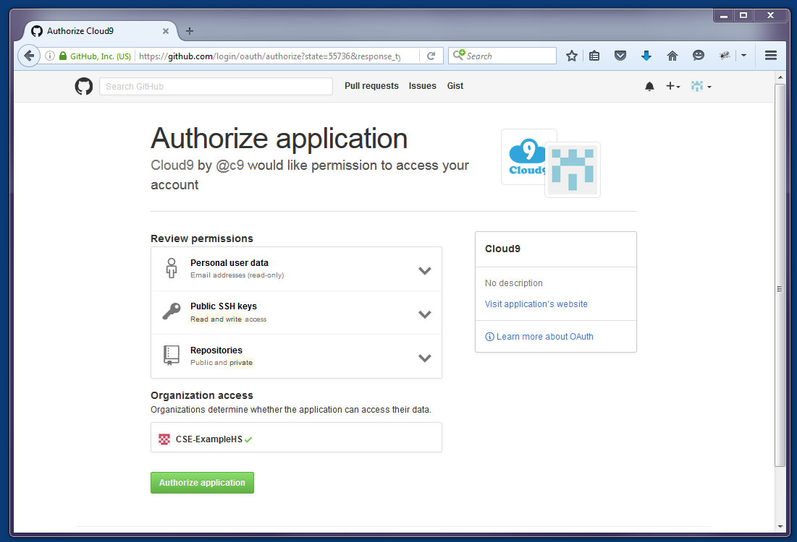

**Part III: Create a Cloud9 workspace from a GitHub repository**

Create a workspace as follows.

1. Select **Create a new workspace** (circled plus sign).

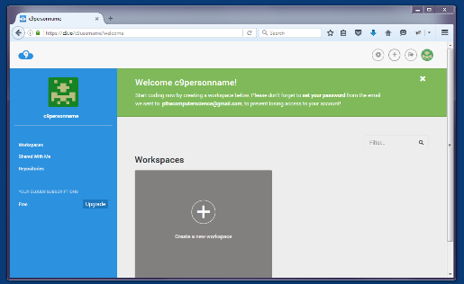

1. Specify the workspace configuration as shown below.
   1. Provide a workspace name (e.g., pltwcsp) using lowercase letters, hyphens, and/or numbers.
   2. Type a Description, select **Private**, clone from GitHub at PLTWCS/csp9.
   3. select the PHP/Apache template.

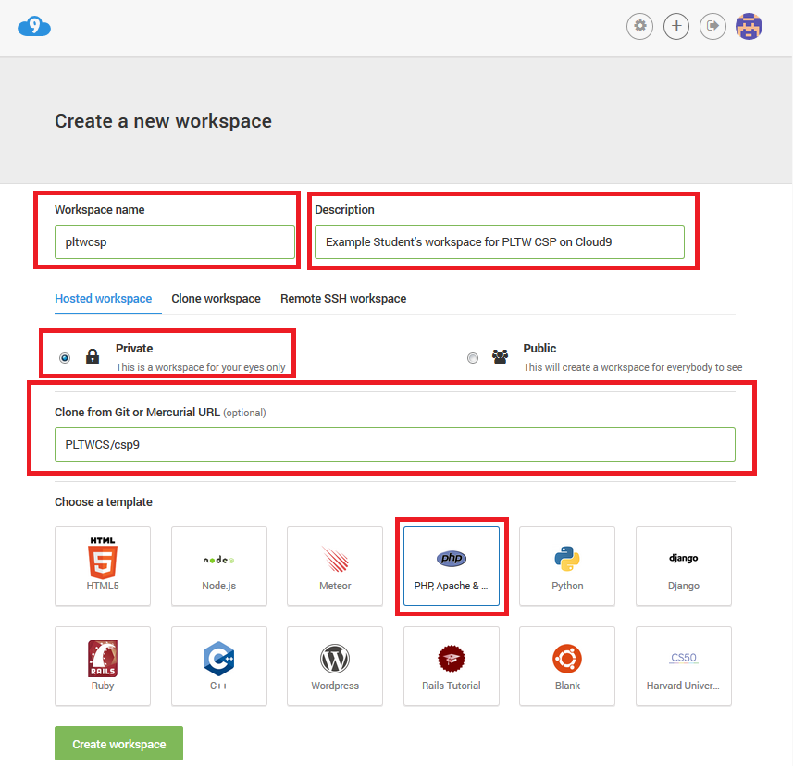

1. Select **Create workspace**.

The workspace may take 1–2 minutes to be provisioned.

1. When the workspace opens, clean up the interface as follows.
   1. Select the top leftmost blinking dot and follow the tour.

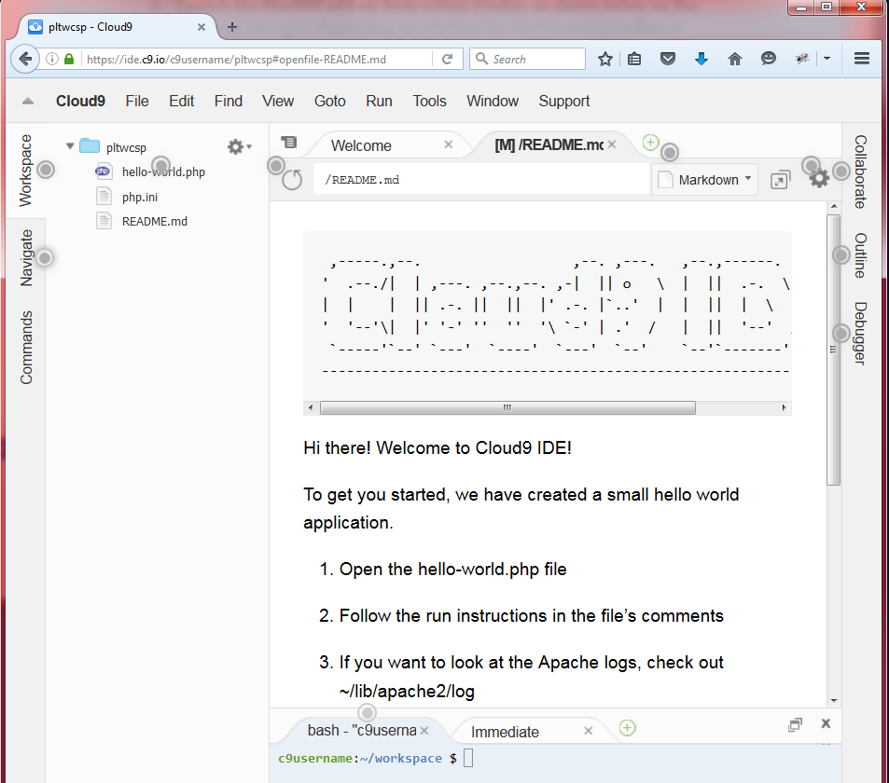

Your workspace starts with four tabs open:

* Welcome
* README.md (a preview tab that renders content from markdown, a markup language like HTML. By convention, a README file describes the contents of the folder it is in.)
* Bash (a terminal tab)
* Immediate (a JavaScript REPL tab)
  1. Close all of the tabs except the Bash terminal tab.
  2. Drag the boundary between the lower and upper panes to make the Bash terminal taller.

1. In the Bash terminal tab, you will type two commands after the $ prompt. The first command makes a file executable, and the second command executes it.
   1. Type chmod 711 initialize.sh to make the initialize script executable.

c9username:~/workspace $ chmod 711 initialize.sh

* 1. Type ./initialize.sh to execute the script. Part of the script changes a password for a database you will use in the next activity. When prompted, enter a password and write it down in a secure location.

c9username:~/workspace $ ./initialize.sh

Your workspace is ready to use.

1. Take note of the following three web addresses, with your Cloud9 username replacing c9username and your workspace name replacing projectname.

* https://ide.c9.io/c9username/projectname

This URL accesses the integrated development environment (IDE).

* https://projectname-c9username.c9users.io/

This URL requests a web page from Apache.

* https://c9.io/c9username

This URL accesses the user’s dashboard.

**Conclusion Questions**

1. How do you manage passwords? Describe your strategy for creating and remembering authentication credentials for a few dozen websites.
2. Describe your cyber hygiene stance. What do you do when using a website requires you to respond to questions about personal information?
3. Judy wanted to watch an episode of the weekly CBS news program *60 minutes*. When she tried to play the video of the episode, the website told her she had to create a free account to continue, as shown in the image below. Based on the browser location bar showing HTTPS and cbsnews.com, Judy correctly trusts that the web page is communicating securely with the CBS company that she knows is legitimate.

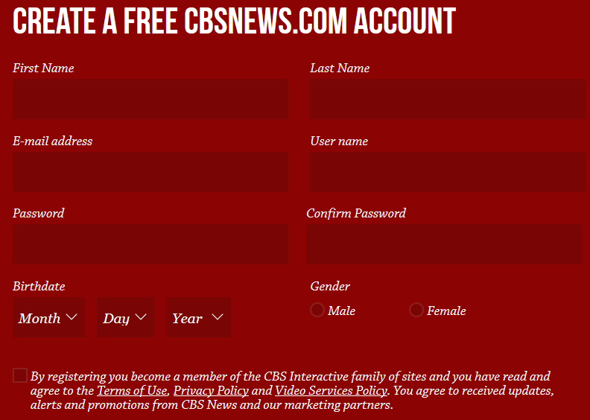

Write advice to Judy about how she should handle this situation.